**Enterprise Application Project Documentation**



**Course:** Enterprise Application Development

**Facilitator:** Trevoir Williams

**Assignment:** Project Documentation, Semester January, 2022

**Team Members:**

**Name:**  **ID #:**

Sanjae Facey 1400137119

Chevernese Muschette 2017002443

Peter-Marc Ricketts

## Entity Profile

S. Facey Fotos is a digital photography company which offers digital photographic services to the general public. The mission statement describes the company’s commitment to providing the highest quality services while taking into keen consideration, the client’s needs and budgetary constraints.

Established in 2019, For the past three (3) years, the services offered by S. Facey Fotos have seen great improvements and with that came a notable growth in the clientele.

## Background

As a growing entity in a digitally evolving commercial environment, S. Facey Fotos recognizes the need to add digital process to their business operations. This will improve processing time, security and customer service.

The current administrative process is limited to paper records and hand to hand transactions. This results in slow, inefficient services and documentation of sales transactions. In recognition of these inadequacies, a software management system was proposed. A desktop application software which will allow for the management of shoot records, booking of shoot, registration of clients and efficient bookkeeping. A web application system was also proposed from which client will be able to register a user account, purchase photography services and receive finished deliverables.

## Assumed Problem

In this fast evolving economy and the growing demand for professional photographic services. Presently, S. Facey Fotos is lacking the current technological infrastructure to efficiently streamline the administrative process while presenting a solution to its clients which offers greater security and ease of use.

## Project Goals

The Desktop Application and Web Application proposes a solution to the issue of security, ease of connectivity between staff and clients and efficient acquisition and delivery of services. This will be achieved by:

* Allowing clients to create secure user accounts from which they will access services provided by S. Facey Fotos.
* Allow for the secure payment for desired services.
* Allow for secure and confidential delivery of finished products
* Allow staff to securely manage client’s user account information.
* Allow staff to securely and efficiently process client’s orders.
* Allow staff to efficiently and securely deliver finished products to clients.
* Allow the enterprise (S. Facey Fotos) to manages sales and client records.

## Problem Analysis and Informative Research

In an effort to fully understand the semantics of the problem, a series of meetings will be held with the management of S. Facey Fotos to discuss the current process in operation and to observe in real time in-office operations in real-time. This process will provide pertinent data to the nature of the speculated problem and aid in the development of the most efficient solution.

## Problem Definition

The proposed solution will rectify the inefficiency of the current business processing methods and enhance the staff and client experience by providing an easy to use, secure technology driven interface with which management and conducting of business will be carried out.

## Proposed Solution and Expected Benefits

The Desktop Application (employing the .NET framework) will provide the following features:

* User-friendly Graphical User Interface for managing user information stored in a secure database.
* Secure Login and the ability to create multiple user accounts.
* Database Management from inside the application without having to open the native database window. This provides some level of data abstraction.
* Provides accurate bookkeeping records.

The Desktop application can only be accessed by the employees of S. Facey Fotos. This management system gives direct access to the Database and will be deployed in the form of an executable installation package.

The Web Application will provide the following features:

* Secure payment portals, quality related content resources, and a robust, user-friendly interface.
* Logical, simple outline which provides a dynamic user experience for clients.
* Fast refresh rate through use of cache memory and cookie technologies
* Search Engine Optimization (SOE) through the use of keyword matching and metadata and social media user data referencing.
* Cross-platform compatibility. That is, the web application will render on any device regardless of screen size or the user’s browser choice.

The Web Application will provide an interface between S. Facey Fotos and the clientele allowing for seamless communication and transactions. This will result in faster turn-around time, greater security and information privacy and greater efficiency in service.

## Application Requirements

|  |  |
| --- | --- |
| Functional | Non-functional |
| * The Application system confirm user action for account creation and all purchase. * The systems payment gateway will allow the client to make purchases. * Confirmation will be given to the client via email and direct message. * The theme of the web app will be customizable to light or dark theme as provided by the browser’s capabilities * The software will be fully integrated with a secure banking system API. * The system will be made accessible to people with disabilities as dictated by the IT Accessibility Laws, Section 508. * The system will provide user validation against S. Facey Fotos user management database | * Portability. The software will be platform and Operating System Independent. * All sensitive data will be audited before exportation. * The web application will be capable of handling at least five million users without any performance or stability issues arising. * The system will be compatible with the minimum system requirements of any computer system. |

## System Requirements

The following system requirements will be met for the design and implementation of the proposed solution.

* The database will be designed using Microsoft Structured Query Language (MSQL)
* The database will cloud-based
* The database will support redundancy and will operate continuously with High Availability support
* The database will feature high end security and guarantee data integrity

## User Interface

The user interface will boast the following features.

* A user friendly interface which is easily navigable
* Clearly labeled links, buttons and meaningful images
* The web-app will be compatible with all monitor sizes
* Provides search option linked to global search engines
* Feature a massage box

## Hardware Requirements

* The web-app will be compatible with any web enabled device

## Software Requirements

* The web-app will be compatible with any web browser.
* A mobile app will be available for download for IOs and Android OS.

## Physical Environment Requirements

* The webserver and the database will be cloud-based

## Response Time

* The system’s response time will be less than 4 seconds.

## Performance

* Resource Utilization will be minimal and accessibly only limited by bandwidth of the user.

## Quality

* Quality of the web-app will comply with international standard as well as modern design and functionality.

## Security

* The web-app will be secured using Secures Socket Layer (SSL) certificate which provides security for online communication and combat Distributed Denial of Service (DDoS) attacks.

## Standards

* The web-app will comply with the standards of the Worldwide Web Consortium (W3C) and the Web Accessibility Initiative (WAI) standards.

## Developer Requirements

* The web-app will be designed using the .NET 6 Model View Controller (MVC) technology which fully supports Java Script, C#, HTML5 among other prominent modern technology.

## Software Design Specification

## The Desktop Application

* Will allow support Creation, Retrieval, Update and Delete (CRUD) functionality
* Will have a user-friendly interface which is easily navigable and learnable for first time users.
* Administrators will be able to perform administrative tasks in maintaining records and authoring user accounts
* The interface will offer text tips on mouse hover on user controls such as links, buttons and text fields
* The various functions should be easily accessible via buttons or a menu strip

ENTITY RELATIONSHIP DIAGRAM (ERD)

Has-A

UserRegistration

packageType

shootTime

cardType

bookingInfo

SEMANTIC OBJECT MODEL DIAGRAMS

**CARDTYPE**

ID# 1.1

Card_Name 1.1

**PACKAGETYPE**

ID# 1.1

Package_Name 1.N

Unit_Cost 1.1

**SHOOT_TIME**

ID# 1.1

Shoot_Time1.1

SEMANTIC OBJECT MODEL DIAGRAMS

**USERREGISTRATION**

ID#1.1

Name

First1.1

Last1.1

Email1.N

Tel# 1.N

Username 1.1

Pass 1.1

Card_Number1.1

Card_TypeID1.1

CSV_Number1.1

Expiration_Date 1.1

**BOOKINGINFO**

ID#1.1

Name

First1.1

Last1.1

Email1.N

Tel#1.N

Card_Number1.1

Card_TypeID1.1

CSV_Number1.1

Expiration_Date 1.1

Package_TypeID 1.1

Shoot_Date

Shoot_TmeID

Shoot_Location

Unit_CostID

Deposit

Total

RELATIONAL TABLES

cardType Table

|  |  |
| --- | --- |
| ID | Card_Name |
|  |  |

|  |  |  |
| --- | --- | --- |
| ID | Package_Name | Unit_Cost |
|  |  |  |

packageType Table

shootTime Table

|  |  |
| --- | --- |
| ID | Shoot_Time |
|  |  |

bookingInfo Table

|  |  |  |  |  |  |  |  |  |
| --- | --- | --- | --- | --- | --- | --- | --- | --- |
| ID | Name | Email_Address | Telehone | Card_Number | Card_TypeID | CSV_Number | Expiration_Date | Package_TypeID |
|  |  |  |  |  |  |  |  |  |

|  |  |  |  |  |  |
| --- | --- | --- | --- | --- | --- |
| Shoot_Date | Shoot_TimeID | Shoot_Location | Unit_CostID | Deposit | Total |
|  |  |  |  |  |  |

userRegistration Table

|  |  |  |  |  |  |  |  |  |  |
| --- | --- | --- | --- | --- | --- | --- | --- | --- | --- |
| ID | Name | Email_Address | Telephone | Username | Pass | Card_Number | Card_TypeID | CSV_Number | Expiration_Date |
|  |  |  |  |  |  |  |  |  |  |

NORMALIZATION TABLES

Credit Card Table

|  |  |
| --- | --- |
| ID | Card_Name |
|  |  |

|  |  |  |
| --- | --- | --- |
| ID | Package_Name | Unit_Cost |
|  |  |  |

Product/Package Table

Table shootTime

|  |  |
| --- | --- |
| ID | Shoot_Time |
|  |  |

Table

|  |  |  |  |  |  |  |  |  |
| --- | --- | --- | --- | --- | --- | --- | --- | --- |
| ID | First_Name | Last_Name | Email_Address | Telephone | Card_Number | Card_TypeID | CSV_Number | Expiration_Date |
|  |  |  |  |  |  |  |  |  |

|  |  |  |  |  |  |  |
| --- | --- | --- | --- | --- | --- | --- |
| Package_TypeID | Shoot_Date | Shoot_TimeID | Shoot_Location | Unit_CostID | Deposit | Total |
|  |  |  |  |  |  |  |

userRegistration Table

|  |  |  |  |  |  |  |  |  |  |
| --- | --- | --- | --- | --- | --- | --- | --- | --- | --- |
| ID | Name | Email_Address | Telephone | Username | Pass | Card_Number | Card_TypeID | CSV_Number | Expiration_Date |
|  |  |  |  |  |  |  |  |  |  |

DATA FLOW DIAGRAM (DFD)

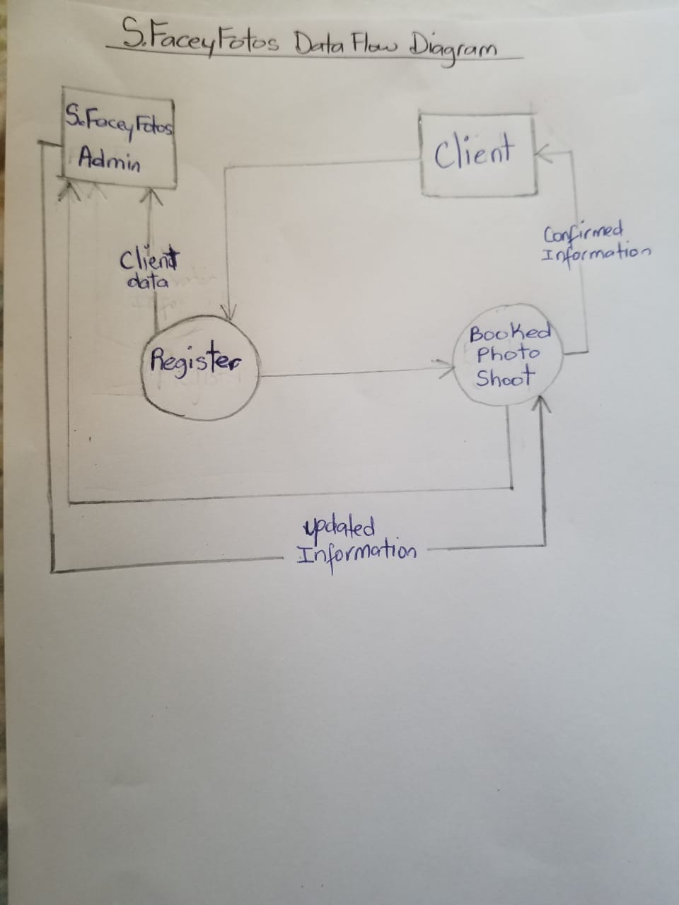

CONTEXT LEVEL DIAGRAM

DATA DICTIONARY

|  |  |  |  |  |  |  |
| --- | --- | --- | --- | --- | --- | --- |
| Table | Column | Data Type | References | Required | Key | Description |
| bookingInfo | ID | int |  | Y | PK | Unique number |
| First_Name | nvarchar(50) |  | Y |  | Client’s first name |
| Last_Name | nvarchar(50) |  | Y |  | Client’s last name |
| Email_Address | nvarchar(50) |  | Y |  | Client’s email address |
| Telephone | nvarchar(50) |  | Y |  | Client’s tel# |
| Card_Number | nvarchar(50) |  | Y |  | Client’s card number |
| Card_TypeID | int | cardType | Y |  | Type card |
| CSV_Number | int |  | Y |  | Card security number |
| Expiration_Date | Date |  | Y |  | Card expiration date |
| Package_TypeID | int | packageType | Y | FK | Package type ID |
| Shoot_Date | Date |  | Y |  | Selected date for shoot |
| Shoot_TimeID | int | shootTime | Y | FK | Shoot time ID |
| Shoot_Location | nvarchar(50) |  | Y |  | Where shoot will be |
| Unit_CostID | int | packageType | Y | FK | Package cost ID |
| Deposit | Decimal |  | Y |  | Amount paid down |
| Total | Decimal |  | Y |  | Package cost |
| cardType | ID | int |  | Y |  | Primary Key |
| Card_Name | nvarchar(50) |  | Y |  | Debit/Credit |
| userRegistration | ID | int |  | Y | PK | Primary key |
| First_Name | nvarchar(50) |  | Y |  | Client’s first name |
| Last_Name | nvarchar(50) |  | Y |  | Client’s surname |
| Email_Address | nvarchar(50) |  | Y |  | Client email |
| Telephone | nvarchar(50) |  | Y |  | User tel# |
| Username | nvarchar(50) |  | Y |  | User name |
| Pass | nvarchar(50) |  | Y |  | User password |
| Card_Number | nvarchar(50) |  | Y |  | Card number |
| Card_TypeID | int | cardType | Y |  | Credit/debit |
| CSV_Number | int |  | Y |  | ?????? |
| Expiration_Date | date |  | Y |  | When card expire |
| packageType | ID | int |  | Y | PK | Primary key |
| Package_Name | nvarchar(50) |  | Y |  | Package selected |
| Unit_Cost | decimal |  | Y |  | Cost of package |
| shootTime | ID | int |  | Y | PK | Primary key |
| Shoot_Time | nvarchar(50) |  | Y |  | Shoot time set |

USE CASE DIAGRAM

Client

BANK

S.FACEY FOTOS

CLASS DIAGRAM